**ABC PANTRY**

**STAKEHOLDERS :**

|  |  |
| --- | --- |
| **ACTOR** | **ACTION IN THE APPLICATION** |
| **CUSTOMER** | 1) SHOULD BE ABLE TO SHOP IN THE NEWLY DESIGNED ABC PANTRY.  2) SHOULD BE ABLE TO SELECT OFFERS AND ADD THE ITEMS TO CART ALONG WITH NON ESSENTIAL PRODUCTS AS WELL. |
| **ADVERTISEMENT SPONSORS** | 1) PROVIDE A EASILY CONTENTED ADVERTISEMENT TO BID ON THE ALLOCATED LOCATION ON THE PAGE. |
| **MANAGEMENT** | 1) MANAGEMENT SHOULD BE ABLE TO EXTRACT REPORTS BASED ON THE PRE-SET REQUIREMENTS. |
| **DELIVERY PERSON** | 1) SHOULD BE ABLE TO IDENTIFY ONLY PAYMENT RECEIVED OR DELIVER THE PRODUCT AND COLLECT CASH IF CASH ON DELIVERY . |

**As- IS STATE :**

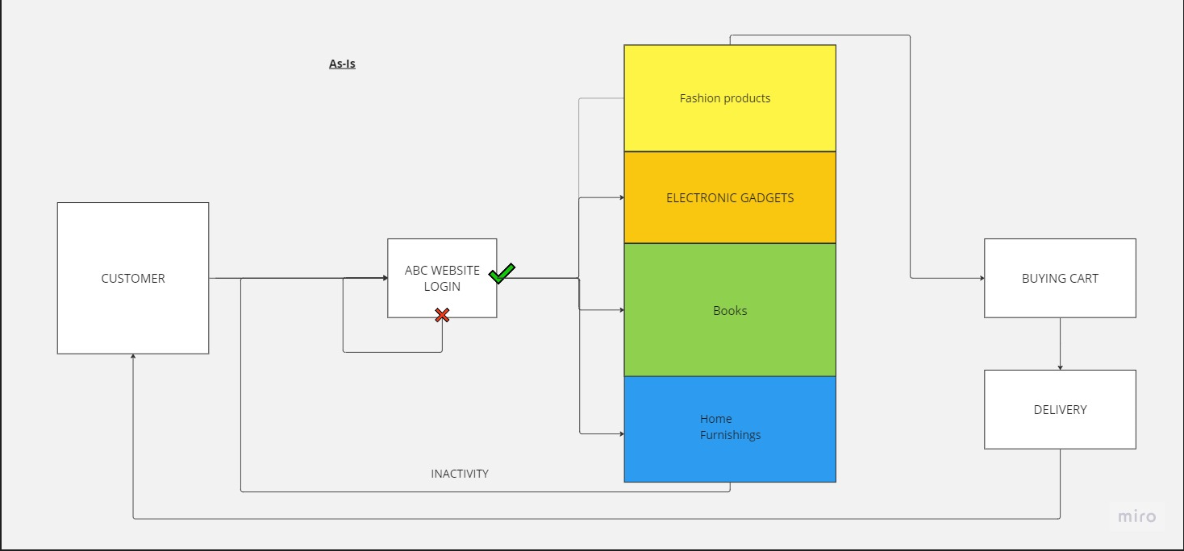

**FUTURE STATE :**

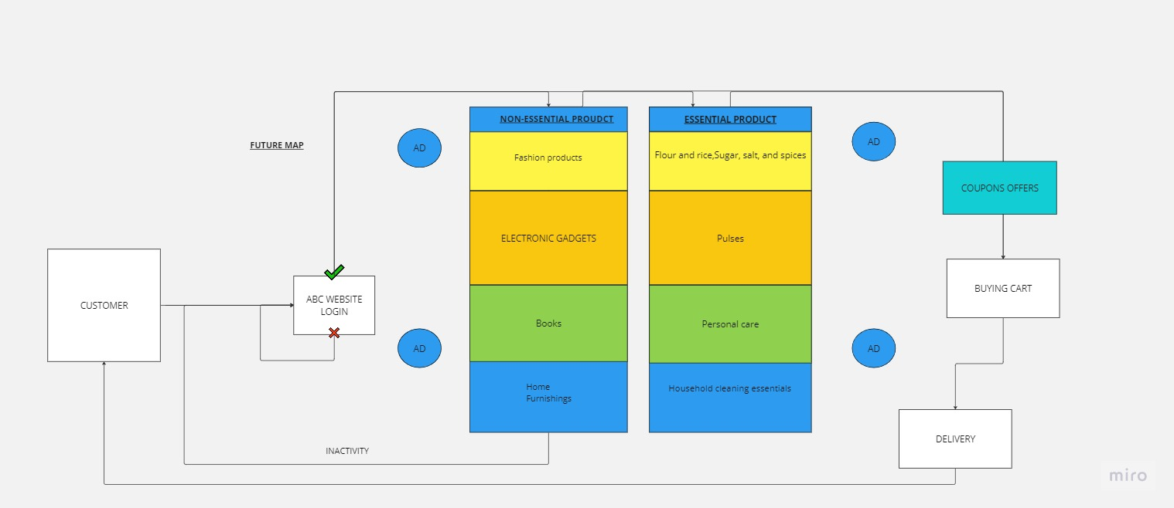

**SCOPE :**

1)New Feature ABC PANTRY needs to be developed in the existing application and website page .

2)The App should be able to let the customers view new enhanced and extra Range categories of

the product.

3)The position of the new feature should be well placed in the website for marketing purpose.

4)The products should be well categorized .

5) The APP and page should be able to present the customer with 5 ADVERTISEMENTS befor their

shopping life cycle ends.

6) The Advertisements should been placed on position which should not deduct the USER

experience.

7) OFFERS should be better than previosu marketing strategies.

8) The APP and website should be able to run automated reports based on the timely requirements.

requirements

Total sales for each day

Total sales for each product category as mentioned in point four.

Total sales across USA

Total sales for each city.

Total sales for each zone that city falls into (that is, zone 1, 2, 3, and 4)

**IN SCOPE :**

1. ABC pantry option.
2. A large expanding category with increase in products .
3. Advertisement placement for advertisement revenues.
4. OFFER’S page visisiblity.
5. REPORT RUNNNING facility for ABC organisation.
6. Shopping cart should be able to collate multiple records of products and buyer purchase .
7. Post purchase details of delivery details .

**Out SCOPE:**

1. SERVER maintenance enhancement due to extra products addition.
2. Security patches for regular cyber update .
3. Faster cyclic redudancy time update .
4. Storage of reports being cached .

**BUISNESS REQUIREMENTS :**

Goals :

ABC Company is the world’s leading online e-commerce company. They started by selling books and now have a presence across the world selling more than 6 million items globally.Most of the products that dominate ABC Company’s sales are non-essential products like fashion products, electronic gadgets, mobile phones, beauty products, books and home furnishings. But ABC Company has realized that every household will need daily essential products like cereals, snacks, beverages, cleaning products, grooming products and so on. ABC Company is seeing a huge market globally in Daily Essential Products and wants to venture into this side of business.

Objectives:

ABC Company decided to create a new feature known as ABC Pantry which would sell daily essential products.

Needs :

This would be an additional enhancement in the current website/app. This would be ABC Company’s foray into daily essential products which are regular consumption products and would lead to repeat sales every month.

**Functional requirments :**

1. Existing system should have a new feature called ABC Pantry.
2. This feature, it would open up a new range and categories of products.
3. Categories that needs to be included in the application .

Flour and rice

Sugar, salt, and spices

Pulses

Personal care

Snacks

Hand wash and sanitizers

Household cleaning essentials

Breakfast food items

Tea and coffee

Baby care

Female hygiene

Tissues and fresheners

1. ABC Pantry should be able to show five advertisements to earn the advertising revenues.
2. ABC Pantry should have a feature to show certain offers that are created for customers. They have found that many customers tend to buy products under the offers laid out by them.
3. Customers should be able to add these items to their shopping cart. This cart may have items from ABC company’s nonessential products as well.
4. The software should not allow the user to place an order of an amount less than 30 USD. Individual items can be less than 30 USD but the total order price has to exceed 30 USD.
5. Free Delivery will be offered only if the total order exceeds 50 USD.
6. Management wants certain reports at the end of the day.

Total sales for each day

Total sales for each product category as mentioned in point four.

Total sales across USA

Total sales for each city.

Total sales for each zone that city falls into (that is, zone 1, 2, 3, and 4)

Identify best-selling categories

Identify the worst-selling categories

Total sales of each week city wise

Identify which day of the week shows highest booking by customers

**Non Functional Requirments :**

1) ABC PANTRY feature should be at a prominent visible area of the existing website or app.

2) logical grouping of products for customers to search for daily essential items they wish to buy.

3) These advertisements should not be too intrusive to spoil the customer.

**WIRE FRAMES :**

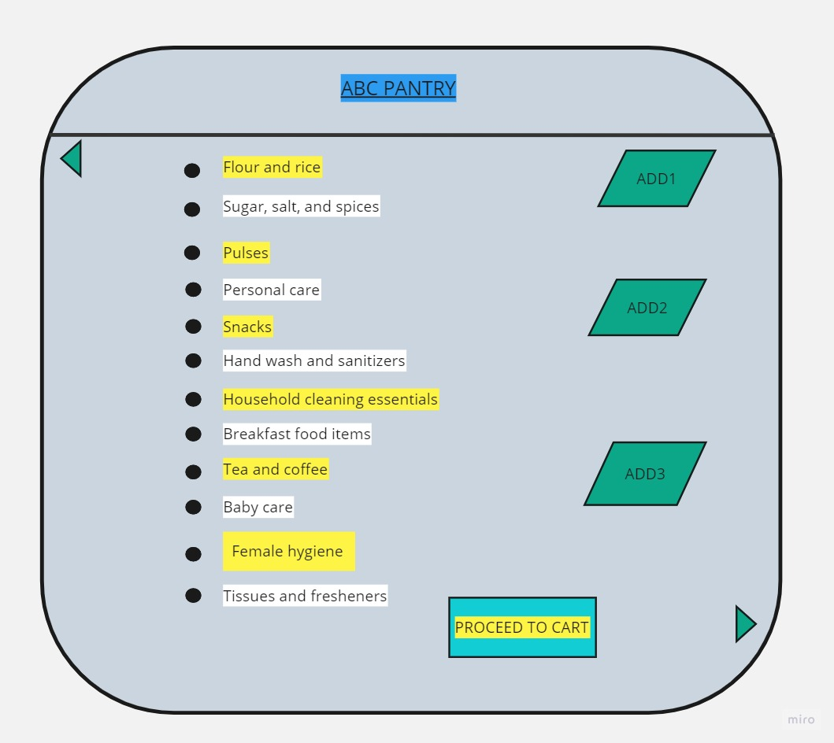**ABC PANTRY PAGE**

**ABC PANTRY CART PAGE :**

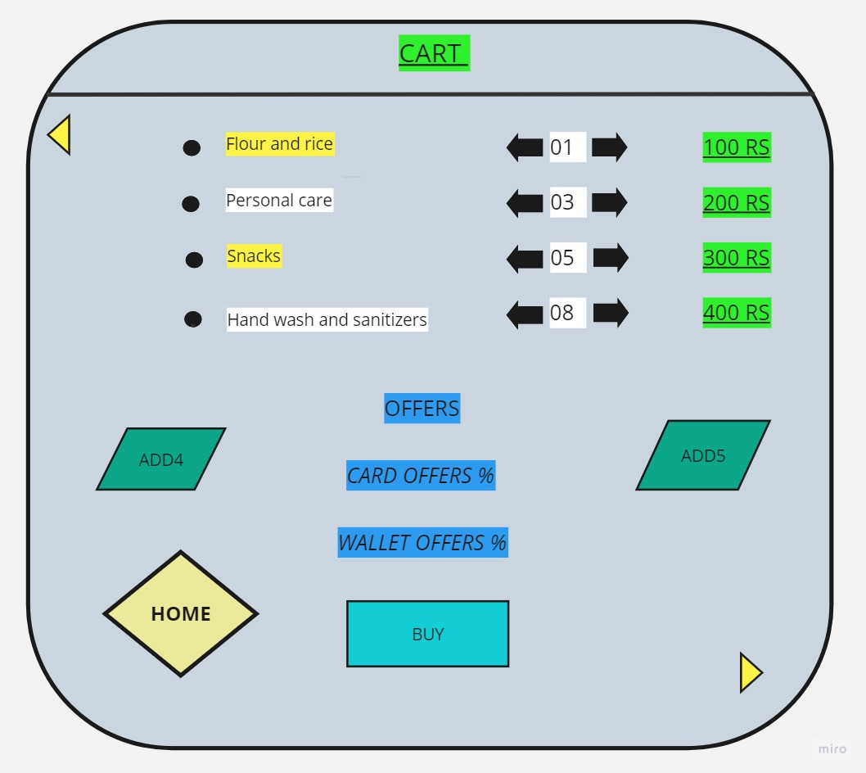

**BACK LOG AGILE USER STORY “AS A””I WANT TO””SO THAT”**

|  |  |  |  |  |
| --- | --- | --- | --- | --- |
| **USER STORY** | **AS A** | **I WANT TO** | **SO THAT** | **STORY POINT** |
| 1 | MANAGEMENT (ABC COMPANY) | BE ABLE TO ANALYZE THE SHOPPING TREND ACCROSS ZONES BY EXTRACTING AUTOMATED REPORTS FROM THE APP/WEBSITE | SO THAT ABC COMPANY CAN VENTURE INTO ESSENTIAL PRODUCTS BUSINESS . | **4** |
| 2 | SOFTWARE DEVELOPER | BE ABLE TO PLACE TOTALLY 5 ADS IN THE WHOLE PURCHASE PROCESS | SO THAT THE ADVERTISEMENTS REVENIEW CAN BE GAINED | **2** |
| 3 | CUSTOMER | BE ABLE TO VIEW AN ABC PANTRY OPTION IN THE EXISTING PAGE | CUSTOMER CAN SHOP DAIL ESSENTIAL PRODUCTS | **1** |
| 4 | CUSTOMER | BE ABLE TO VIEW OFFER PAGES FROM ABC PANTRY WHILE SHOPPING | SO THAT THE OFFERS CAN BE UTILIZED | **3** |

|  |  |
| --- | --- |
| **USER STROY** | **ACCEPTANCE CRITERIA** |
| 1 | AS A BUSINESS RUNNER WHEN THEY OPEN THE REPORT PAGE , THEY SHOULD BE ABLE TO RUN REPORTS BASED ON THE CRITERIA REQUIRED. THE CRITERIA WILL BE BASED ON CITY ZONES AND DATES . THE REPORT PAGE WILL SHOW OPTION "ZONE" & "DATE" FOR THE MANAGEMENT TO SELECT . |
| 2 | AS A SOFTWARE DEVELOPER , THE PERSON SHOULD BE ABLE TO PLACE THE ADVERTISEMENTS IN PAGE AS PER THE WIRES CREATED BY THE BUISNESS ANALYSTS.THE ADVERTISEMENTS SHOULD BE ABLE TO POP UP AND MAXIMIXE WHEN THE CUSTOMER WANTS TO VIEW IT . IF NOT THE ADVERTISEMENT SHOULD BE INSIDE THE MINIMIZED POP-IP |
| 3 | THE CUSTOMER WHEN OPENS THE ABC WEBSITE THEY SHOULD BE ABLE TO VIEW THE NEW PANTRY OPTION, ONCE OPENED THE ESSNETIAL PRODUCTS SHOULD BE LOGICALLY CATEGORIZED .THE PAGE SHOULD LEAD TO CART AND THE CART SHOULD BE ABLE TO ADD ALL ESSENTIAL AND NON ESSENTIAL PRODUCTS |
| 4 | THE CUSTOMER SHOULD BE ABLE TO VIEW OFFERS IN A SEPERATE PAGER ONCE THE CART IS LOADED , THE OFFERS SHOULD BE TOTALLY BASED ON THEIR CREDIT CARD OR WALLET MODE OF PAYMENT. |

**TABLEAU**

1. Dashboard for senior management for Chicago to view sales of personal care products for the last 6 months

https://public.tableau.com/views/CHICAGO6MONTHSSALES/Dashboard1?:language=en-US&publish=yes&:display_count=n&:origin=viz_share_link

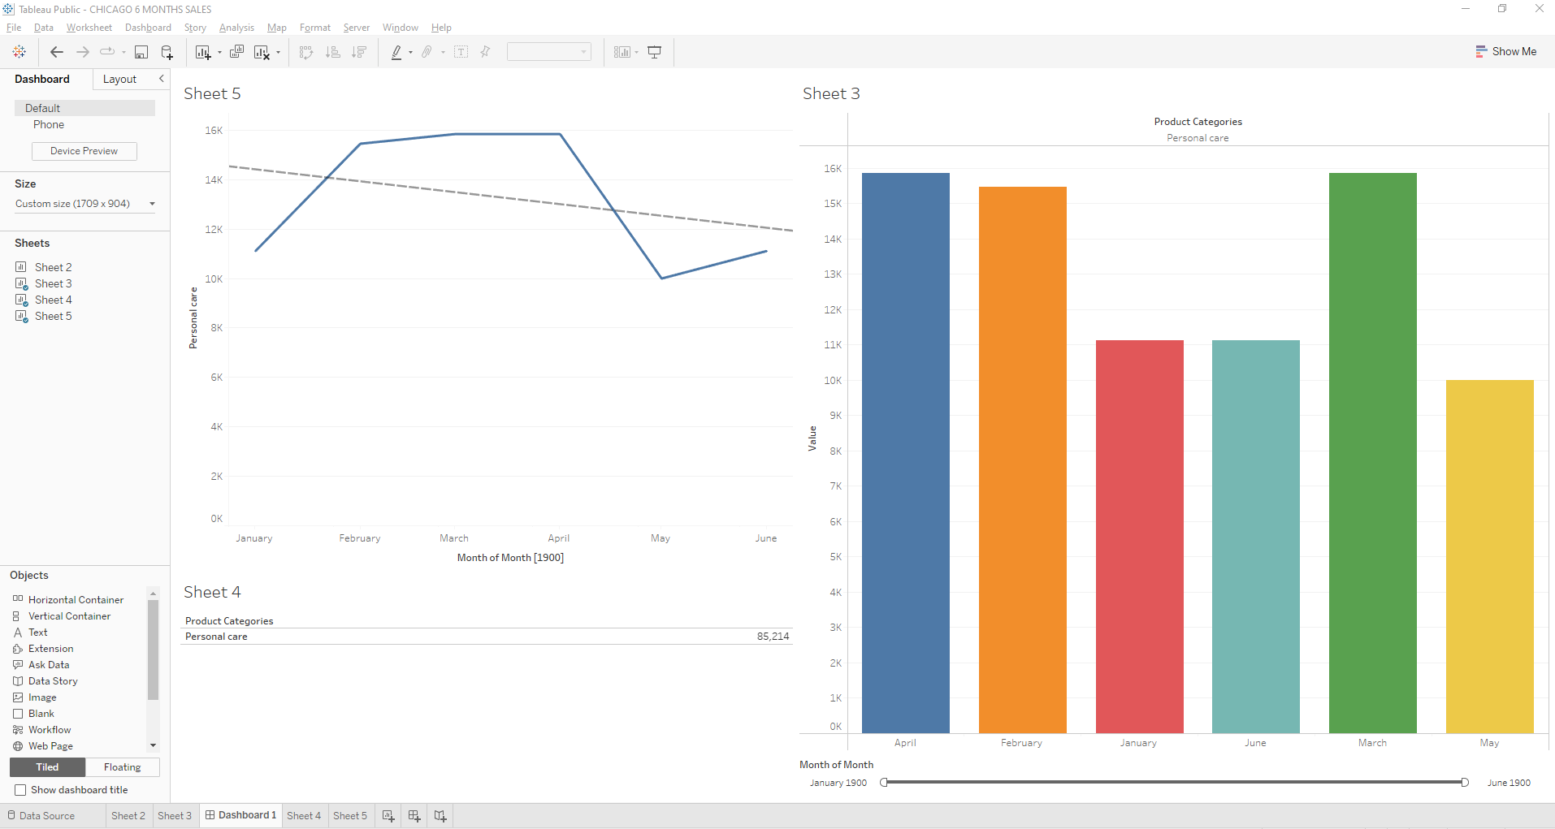

1. Dashboard to show Senior Management for Chicago to view sales of breakfast products for the last six months.

https://public.tableau.com/views/breakfastdashboard/Dashboard1?:language=en-US&publish=yes&:display_count=n&:origin=viz_share_link

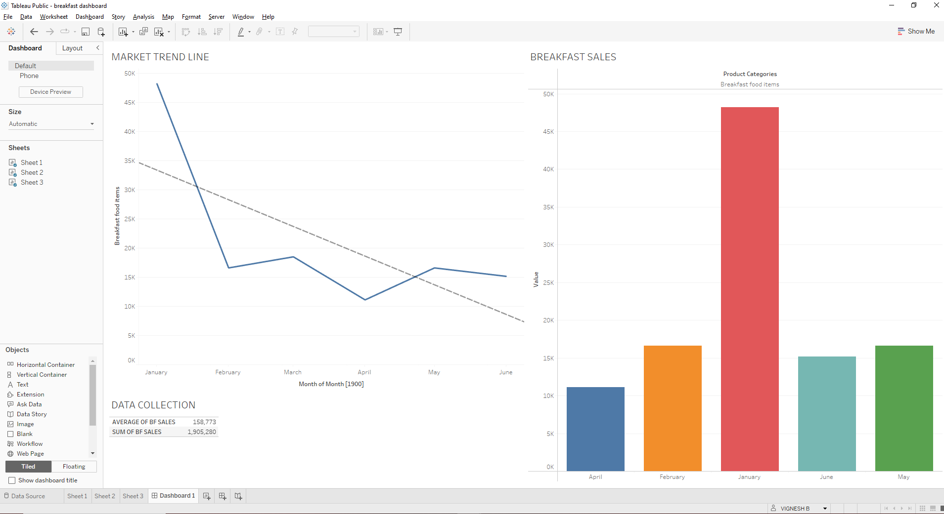

EXCEL SHEET QUESTIONS :

